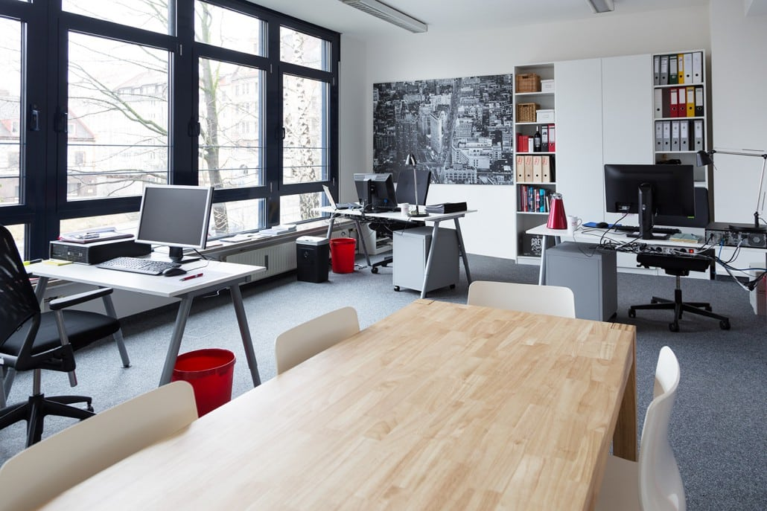
Administration employee

Administration is an
important part of every
company.
Every company has got
administration employees.

They usually work in an office.
Their main tasks are to answer phone calls, help visitors, give advice and to work with computers (check e-mails,…).

The duration of this training is three years and starts in a school, where you are able to learn more about the job and start to practise for it.
During this time the students are able to discover many departments of the job. It is an occasion to decide, which department fits every student.

An employee, who works for a company has got a lot of contact to the visitors and has to communicate with them.
You have to be always friendly, polite but also patient, orderly and independly.
Salary: 1.800-2.000 euro



